1.SWAP SALARY

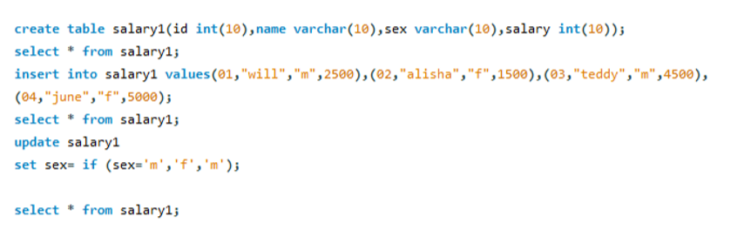

2. .GAME PLAY ANALYSIS I

